Assignment 2

Divyank Sharma

**Exercise 1 – Running code and outputs**

Server Terminal - python3 template-server.py

After ending 1 connection with the client:

num_users decrements to 1:

Client Terminal - python3 template-client.py

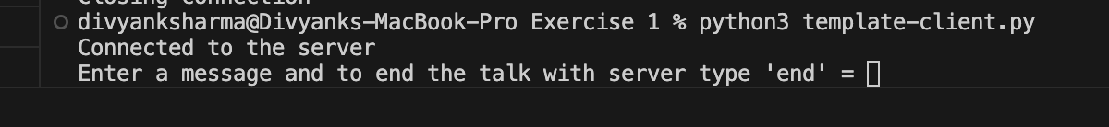

**Exercise 2**

1. Installing protobuf from pip3 - pip3 install protobuf
2. Creating Protobuf file and compiling it

syntax = "proto3";

message Message {

int32 fr = 1; // Sender ID

int32 to = 2; // Receiver ID

string msg = 3; // Message content

}

1. Compiling the .protofile - protoc --python_out=. msgFormat.proto

Server Terminal –

Running the server file: python3 server.py

OUTPUT -

2002 is allocated to the server

Client Terminal – python3 client.py

**Exercise 3**

1. Installing protobuf from pip3 - pip3 install protobuf
2. Creating Protobuf file and compiling it

syntax = "proto3";

message Message {

int32 fr = 1; // Sender ID

int32 to = 2; // Receiver ID

string msg = 3; // Message content

}

message Handshake {

int32 id = 1; // Handshake ID

bool error = 2; // Error flag

}

1. Compiling the .protofile - protoc --python_out=. msgFormat.proto

Server Terminal –

Running the server file: python3 server.py

Client Terminal – python3 client.py

